

SNAPSHOT

Benefits for All?:

Addressing Issues of Inclusion & Trust for Equitable Access to Precision Medicine

Adapted for PBS LearningMedia in partnership with WETA for use with

2020

# A picture containing food, drawing Description automatically generatedSNAPSHOT

Benefits for All?:

Addressing Issues of Inclusion & Trust for Equitable Access to Precision Medicine

Adapted for PBS LearningMedia in partnership with WETA for use with

## The Big Picture

* What are the opportunities that genetics may bring for diagnosing, treating, and preventing disease?
* What are the challenges for making genetic testing and therapies available to all who want them?

### Genetic tools are bringing opportunities to improve health as well as concerns about equity and fairness.

**Do Now:** Watch [this clip](https://mass.pbslearningmedia.org/resource/5f934c6f-ea85-4a22-9329-3a074475d9cf/history-access-to-care-and-emerging-genetic-based-therapies/support-materials/) from the PBS documentary, *The Gene: An Intimate History*, to learn about the possibilities of using a person's genetic make-up to inform their health care as well as the concerns about access and reducing the risks of harm to people involved in or impacted by genetic research.

**Technological developments are making it possible to read a person’s entire genetic code, or genome, more rapidly and at a lower cost than ever before.** Personal genome sequencing is allowing scientists and doctors to better understand the connections between genes and human health, improve medical care, and help extend people’s lives. These ideas are broadly known as “precision medicine”. The hope is the cost of genetic analysis will become so low that information about a person's genetic make-up could become a routine part of the puzzle in making decisions about their medical care.

**However, many people in the US, across ethnic groups, cannot access the healthcare they need.** For example, between 11-25% of people in a 2014 study from the Kaiser Family Foundation admitted not seeing a doctor for needed care due to cost. According to the US Census, “In 2018, 8.5% of people, or 27.5 million, did not have health insurance at any point in the year”. The full potential of personal genetics to improve health will remain out of reach for many people until these underlying issues of access and economics are addressed.

**New therapies for genetic conditions can be very expensive, resulting in limited access for most people.** For example,in 2016 and 2019, two new therapies for the serious and sometimes-fatal genetic condition, Spinal Muscular Atrophy, came to market. One treatment involves a single dose that costs $2.1 million dollars. The other treatment is needed on an on-going basis, costing $750,000 for the first year and then $375,000 for each year thereafter. While some people might have insurance that covers part or all of the costs, many people who would benefit from this treatment are currently unable to do so.

### Beyond economic disparities: Past abuses have created distrust of biomedical researchers, particularly in communities of color.

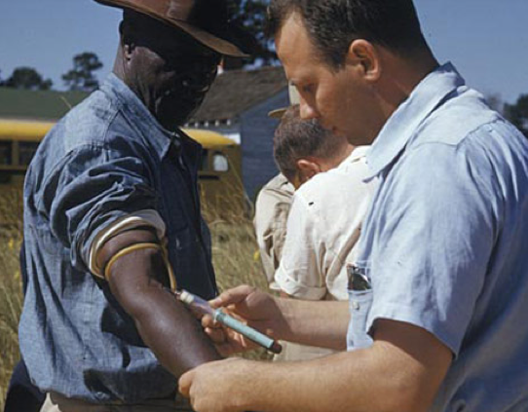The Tuskegee Syphilis Study was a study of how untreated syphilis (a sexually transmitted bacterial infection) impacted the health of people living with the disease. The study was run by the US Public Health Service from 1932-1972. Over 600 African American men with syphilis were enrolled in the study and were offered free healthcare and insurance to cover the costs of burial services in return for their participation. Many of the men were not told they were part of a research study. They were not informed about the risks or told they could leave the study. Even though penicillin was the standard drug given to treat syphilis by 1947, it was not given to the men in the study.

Image: Centers for Disease Control   
and Prevention (Public Domain)

The Tuskegee Syphilis study came to an end in 1972 after it was reported in the press. It is considered one of the most terrible human experiments in the United States. The men were not given the chance for a fair and informed consent process, and an available treatment was withheld from them for 25 years. Many of the men died, 40 of their wives were infected as well, and 19 children were born with congenital syphilis. In response, a national commission was formed, in part, to consider how the system allowed the Tuskegee study to happen. This commission produced the 1979 *Belmont Report*  that provided clear rules for informed consent and supervision of research involving human subjects. President Clinton formally apologized to the survivors in 1997.

The Tuskegee Syphilis Study has left a legacy of distrust with the healthcare and medical research systems. Other examples include the painful history of the American eugenics movement, the story of Henrietta Lacks, and the abuses by Dr. Marion Sims, considered a pioneer in women’s reproductive medicine but whose work relied on brutally painful and repetitive surgeries on enslaved women during the 1850s in the US. This legacy of distrust is one reason that there is a much lower rate of participation in genetic research and clinical trials among ethnic minorities compared to people of European descent.

Curious to learn more? Here are some additional sources:

* "[How the Public Learned about the Tuskegee Syphilis Study](http://time.com/4867267/tuskegee-syphilis-study/)", by Olivia Waxman, July 2017, *Time.*
* [Image Archive on the American Eugenics Movement](http://www.eugenicsarchive.org/eugenics/) maintained by the DNA Learning Center, *Cold Spring Harbor Laboratory*.
* [Home page for the family of Henrietta Lacks](http://www.lacksfamily.net/henrietta.php), maintained by the Lacks family.
* "[The ‘Father of Modern Gynecology’ Performed Shocking Experiments on Slaves](https://www.history.com/news/the-father-of-modern-gynecology-performed-shocking-experiments-on-slaves)", by Brynn Holland, August 2017 (updated December 2018), *History.com*.
* "[In Cancer Trials, Minorities Face Extra Hurdles](https://www.nytimes.com/2016/12/23/health/cancer-trials-immunotherapy.html)", by Denise Grady, December 2016, *New York Times*.

### Some scientists are trying to increase representation in research and build bridges with communities that have been hurt by past abuses.

The clip from*The Gene: An Intimate History* highlights one of these efforts, the *All of Us* research program from the National Institutes of Health. *All of Us* seeks to enroll and collect detailed medical and health information on one million diverse research participants – including their genetic profile. This is part of an effort to develop healthcare options that are more precisely tailored to individual needs. Having a million people participate will help researchers to better understand the complicated connections between people's genetic make-up and their health status. The hope of the *All of Us* program and other similar projects is that they could one day allow all people to have more tailored information about their health risks and their likely responses to medicine and therapies.

**Read this article:** "[To advance medicine’s future, the NIH tries to win the trust of communities mistreated in the past](https://www.statnews.com/2017/09/22/nih-precision-medicine-all-of-us/)", by Lev Facher, September 2017, *STAT News*.

**Benefits for All?: Addressing Issues of Inclusion & Trust for Equitable Access to Precision Medicine**

# STUDENT HANDOUT

Name: _____________________________________ Date: ________________

1. In *The Gene* clip, what is the name of the approach called of using individualized screenings and data, and avoiding the “one-size-fits-all” approach for health interventions?
2. In *The Gene*, Dr. Alondra Nelson is quoted, saying, “Genetics, because of it being the sort of core of who we are, of course gets mobilized into ideas of human perfection- and a kind of fantasy about being able to perfect ourselves, and perfect our children, and our children’s children”. In your own words, what do you think Dr. Nelson is saying?
3. List two examples of why the Tuskegee Syphilis Study is considered one of the most terrible and harmful human experiments in the history of the US?
4. Based on the article from *STAT News*, list two examples of how researchers are seeking to build trust with people and communities who may benefit from participating in genetic research, but who are skeptical. What are two challenges the researchers face?