SNAPSHOT

The Common Thread:
DNA and Human Variation

Student Materials – pages 2-3
Teacher Guide – pages 4-5

SNAPSHOT

The Common Thread:

DNA and Human Variation

The Big Picture
In recent years, scientists have made stunning breakthroughs in developing new tools for analyzing people’s DNA. These technologies are allowing scientists and doctors to better understand the connections between genes and human health. Increasingly, people can consider using these tools to improve their medical care. People can also use these tools to explore their ancestry and find biological relatives.

DNA and Human Variation
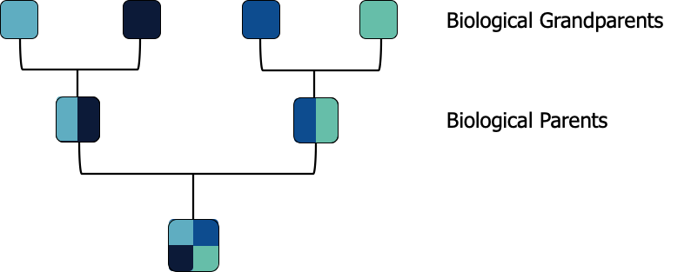
Your DNA code is a mix of the DNA from your biological parents. In turn, your biological parents each have a mix of DNA from their biological parents, who are your biological grandparents (Figure 1). Because a person’s DNA is inherited in this way, across generations, it can provide clues about their ancestry.
Figure 1 – DNA is inherited across generations.

As scientists analyze DNA from more and more people, they are developing a better understanding of human genetic variation. How similar are two people’s DNA code? How much do they differ? What does human genetic variation look like across the world?
Watch the following video and answer the questions on the student worksheet.
- The Common Thread: DNA and Human Variation
The Common Thread: DNA and Human Variation

STUDENT WORKSHEET
Name: _____________________________________ Date: ________________
- What is a genetic variant?

- How much of your DNA code is identical to DNA from other people around the world?

- True or false: Most of the DNA variants that have been found are present in populations across the world.

- True or false: There are some DNA variants that are unique to certain populations that can be used to define the population in a country or continent as a whole.

- One reason why people differ from each other is because of variants in our DNA code. Name at least 2 other factors that contribute to human diversity.
The Common Thread: DNA and Human Variation

TEACHER’S GUIDE

Foundational concept
Although this lesson’s focus is on the contribution of DNA to human variation, it is important to recognize that your physical, mental and behavioral traits are influenced both by your genetic make-up and by the unique circumstances in which you have lived your life, including everything that has ever happened to you. We often refer to these two inputs as “nature,” the genome you carry that is unique to you, and “nurture,” the environment in which you have lived your life. However, “nature” and “nurture” are not independent of each other – environmental factors affect how genes are “expressed” (turned on or off), and even lead directly to changes in your DNA sequence. The intricate and sometimes unclear relationship between genetics and environment is key to our understanding of behavior and health. Researchers are seeking to study the genome sequences and characteristics of many people to develop a better understanding of the interplay of nature and nurture in known diseases, with the hope that this would lead to better treatments, cures, preventative measures and healthier generations of children.

Related pgEd lesson plans
- This SNAPSHOT was adapted for PBS LearningMedia in partnership with WETA and paired with a clip from Finding Your Roots – Season 7.

The Common Thread: DNA and Human Variation

STUDENT WORKSHEET TEACHER NOTES
What is a genetic variant?
A genetic variant is a difference in the DNA code.
How much of your DNA code is identical to DNA from other people around the world?
More than 99%
True or false: Most of the DNA variants that have been found are present in populations across the world.
True - though the frequency at which they exist in each population might differ (i.e. some variants are more common in one population than they are in another).
True or false: There are some DNA variants that are unique to certain populations that can be used to define the population in a country or continent as a whole.
False - There are indeed some DNA variants that are unique to certain populations, but they have only been found in some members of that population and can therefore not be used to define the population in a country or continent as a whole.
One reason why people differ from each other is because of variants in our DNA code. Name at least 2 other factors that contribute to human diversity.
There are many factors outside of DNA variants that contribute to human diversity, including but not limited to: the environment you grow up in, the foods you eat, the languages you speak, cultures and traditions, the people you meet your life experiences and so on.

